Multimodal Financial Intelligence RAG System-RAG-gemini-3.6-flash

Project Description:
Multimodal Financial Intelligence RAG System harnesses multimodal Generative AI to provide intelligent, grounded question-answering over financial documents such as annual reports, 10-Ks, and earnings decks. The platform includes an Ingestion & Understanding module, which extracts narrative text, structured tables, and chart/image elements from a PDF and uses a multimodal AI model to interpret the data embedded inside chart images, a Hybrid Retrieval module, which automatically detects financial intent in a query and retrieves the most relevant mix of text, table, and chart-derived content, and a Grounded Generation module, which synthesizes a clear, analyst-style answer with explicit page-level citations for every claim.
Utilizing Google's Gemini API for both multimodal chart understanding and text generation, Multimodal Financial Intelligence RAG System processes lengthy financial reports to deliver fast, accurate, and verifiable answers. Built with FastAPI for the backend API and Streamlit for the analyst-facing interface, and backed by a persistent ChromaDB vector store, the platform ensures a seamless and trustworthy experience. With secure API key management via .env and citation-backed answers that flag when supporting data is insufficient, Multimodal Financial Intelligence RAG System empowers financial analysts to interrogate lengthy reports — including the information locked inside their charts and images — with confidence.
Scenarios
Scenario 1: An analyst asks “What was NVIDIA's 5-year total shareholder return?” — a figure that exists only as a bar in a chart image, nowhere in the report's narrative text. The system retrieves the chart element, reads Gemini's earlier extraction of the underlying data points, and returns “238%” with a citation pointing to the exact chart, page, and document.
Scenario 2: An analyst asks “Why did NVIDIA's gross margin decline in fiscal year 2023?” — an explanation that lives entirely in narrative text. The system correctly retrieves only text elements (inventory charges, supply-chain cost commentary) and cites the relevant paragraphs, without forcing an irrelevant chart citation.
Scenario 3: An analyst asks about board diversity and capital allocation, questions whose answers are split between a donut-chart infographic and supporting narrative text. The system blends both modalities into a single coherent answer, citing the pie chart for headline percentages and the text for supporting policy context — demonstrating true multimodal retrieval rather than a single-source lookup.

Technical Architecture:
Description:
Multimodal Financial Intelligence RAG System uses a six-stage pipeline: PyMuPDF extracts text, tables, and charts from a PDF; Gemini reads chart images into structured data and embeds everything (text + CLIP image embeddings) into ChromaDB. At query time, a hybrid retrieval layer finds the most relevant elements and Gemini generates a citation-backed answer, served through a FastAPI backend and Streamlit interface.
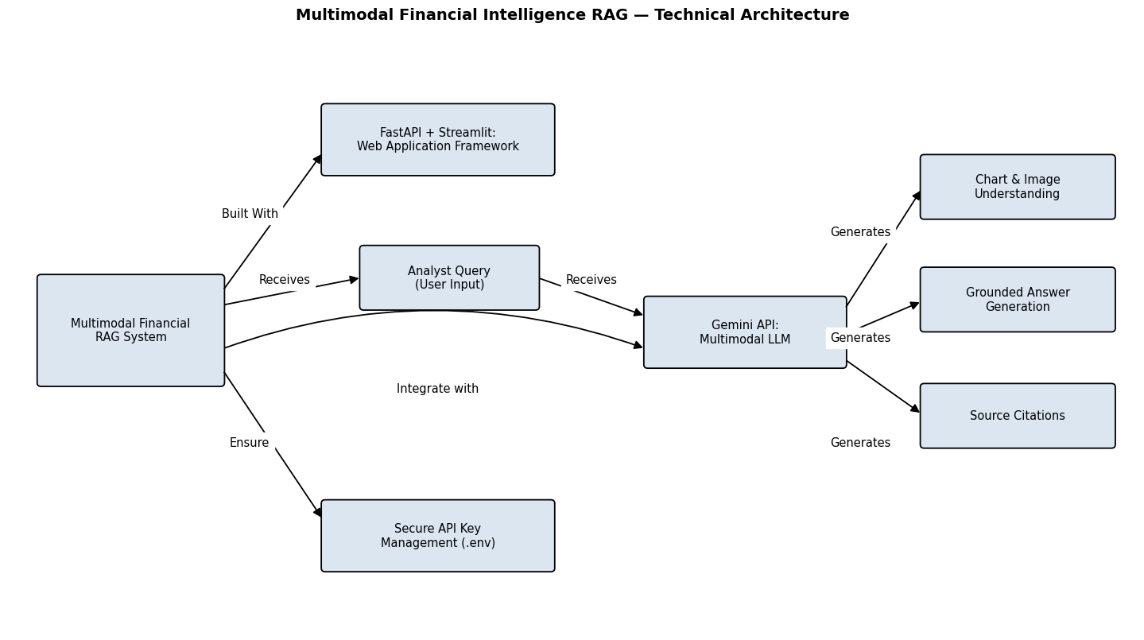
Pre-requisites:
- Python Programming Proficiency: https://docs.python.org/3/
- FastAPI Framework Knowledge: https://fastapi.tiangolo.com/
- Streamlit Framework Knowledge: https://docs.streamlit.io/
- Google Gemini API Familiarity: https://ai.google.dev/gemini-api/docs
- PDF Processing with PyMuPDF: https://pymupdf.readthedocs.io/
- Vector Databases (ChromaDB): https://docs.trychroma.com/
- Version Control with Git: https://git-scm.com/doc
- Development Environment Setup: https://docs.python.org/3/library/venv.html

Project Workflow:
Milestone 1: Model Selection and Architecture
- Activity 1.1: Generate a Google Gemini API key and configure it securely in the project environment.
- Activity 1.2: Research and select the appropriate Gemini models for multimodal chart understanding and text embeddings.
- Activity 1.3: Define the architecture of the application, detailing interactions between ingestion, understanding, indexing, retrieval, generation, and the interface layers.
- Activity 1.4: Set up the development environment, installing necessary libraries and dependencies for FastAPI, ChromaDB, PyMuPDF, and the Gemini SDK.
Milestone 2: Core Functionalities Development
- Activity 2.1: Develop the core functionalities: PDF Ingestion & Extraction, Chart & Image Understanding, and Hybrid Semantic Retrieval.
- Activity 2.2: Implement the indexing and vector storage layer, ensuring smooth embedding generation and ChromaDB interactions.
Milestone 3: Core Pipeline Development
- Activity 3.1: Write the core orchestration logic across the ingestion, understanding, indexing, retrieval, and generation pipeline modules, and expose them via the FastAPI application.
Milestone 4: Frontend Development
- Activity 4.1: Design and develop the analyst-facing user interface using Streamlit, ensuring a clean and intuitive layout.
- Activity 4.2: Create dynamic result rendering to display grounded answers with expandable, page-linked source citations.
Milestone 5: Deployment
- Activity 5.1: Prepare the application for local deployment by configuring the server environment and ensuring all dependencies are correctly installed.
- Activity 5.2: Run and verify the FastAPI backend and Streamlit interface locally, testing end-to-end query and ingestion flows.
Milestone 6: Conclusion

Milestone 1: Model Selection and Architecture
In this milestone, we focus on selecting the appropriate Gemini models for our multimodal financial document understanding needs. This involves researching the capabilities of Google's available Gemini models, ensuring the chosen models align with the application's objectives of reading chart images, generating text embeddings, and synthesizing grounded, analyst-toned answers.
Activity 1.1: Generate a Gemini API Key
Before the application can communicate with the Gemini API, a valid API key is required. Follow the steps below to create one and connect it securely to the project.
- Step 1 — Create a Google AI Studio Account: Visit https://aistudio.google.com and sign in with a Google account.
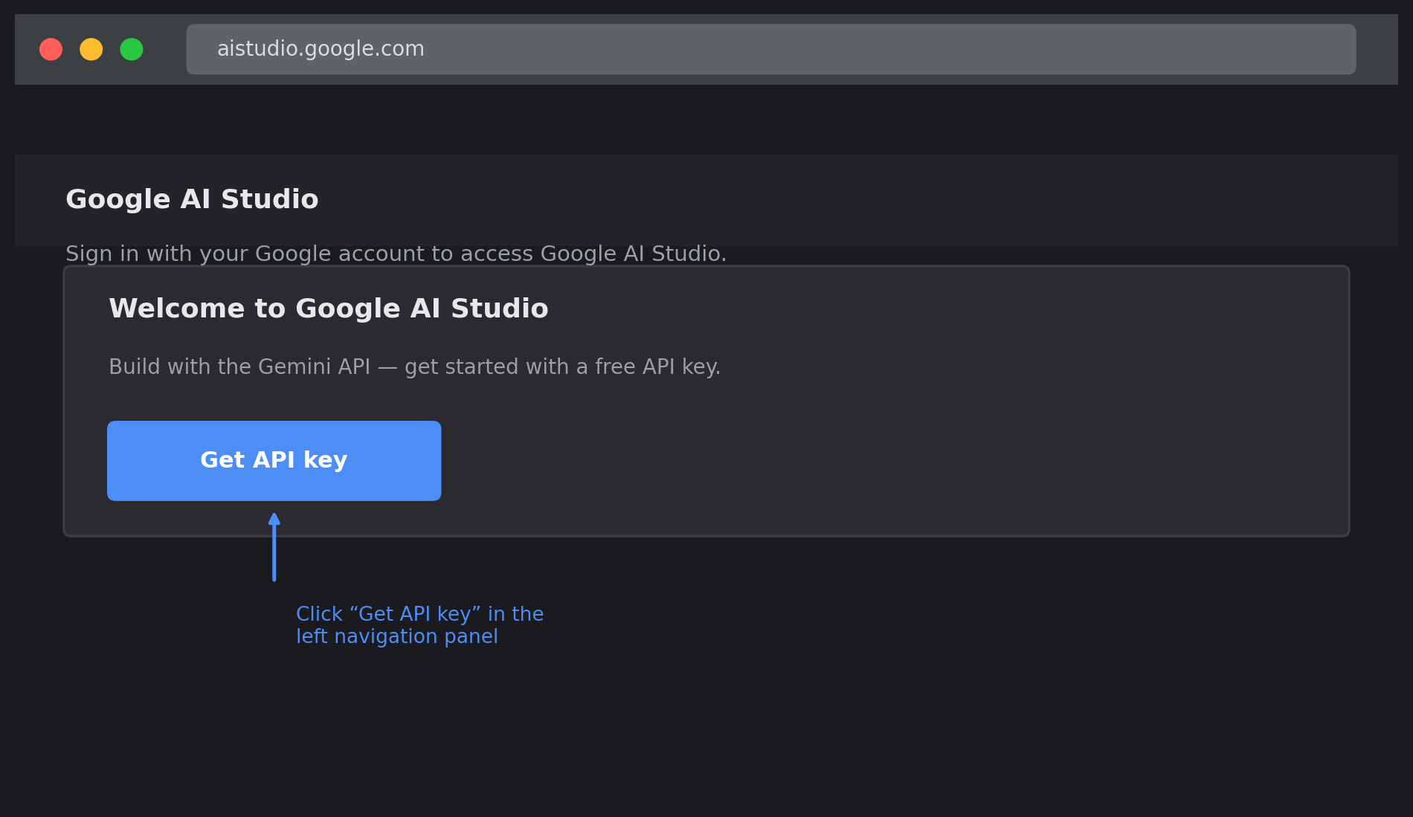
Figure — Illustrative reference: the Google AI Studio landing page with the “Get API key” entry point.
- Step 2 — Navigate to API Keys: Click “Get API key” from the left-hand navigation menu.
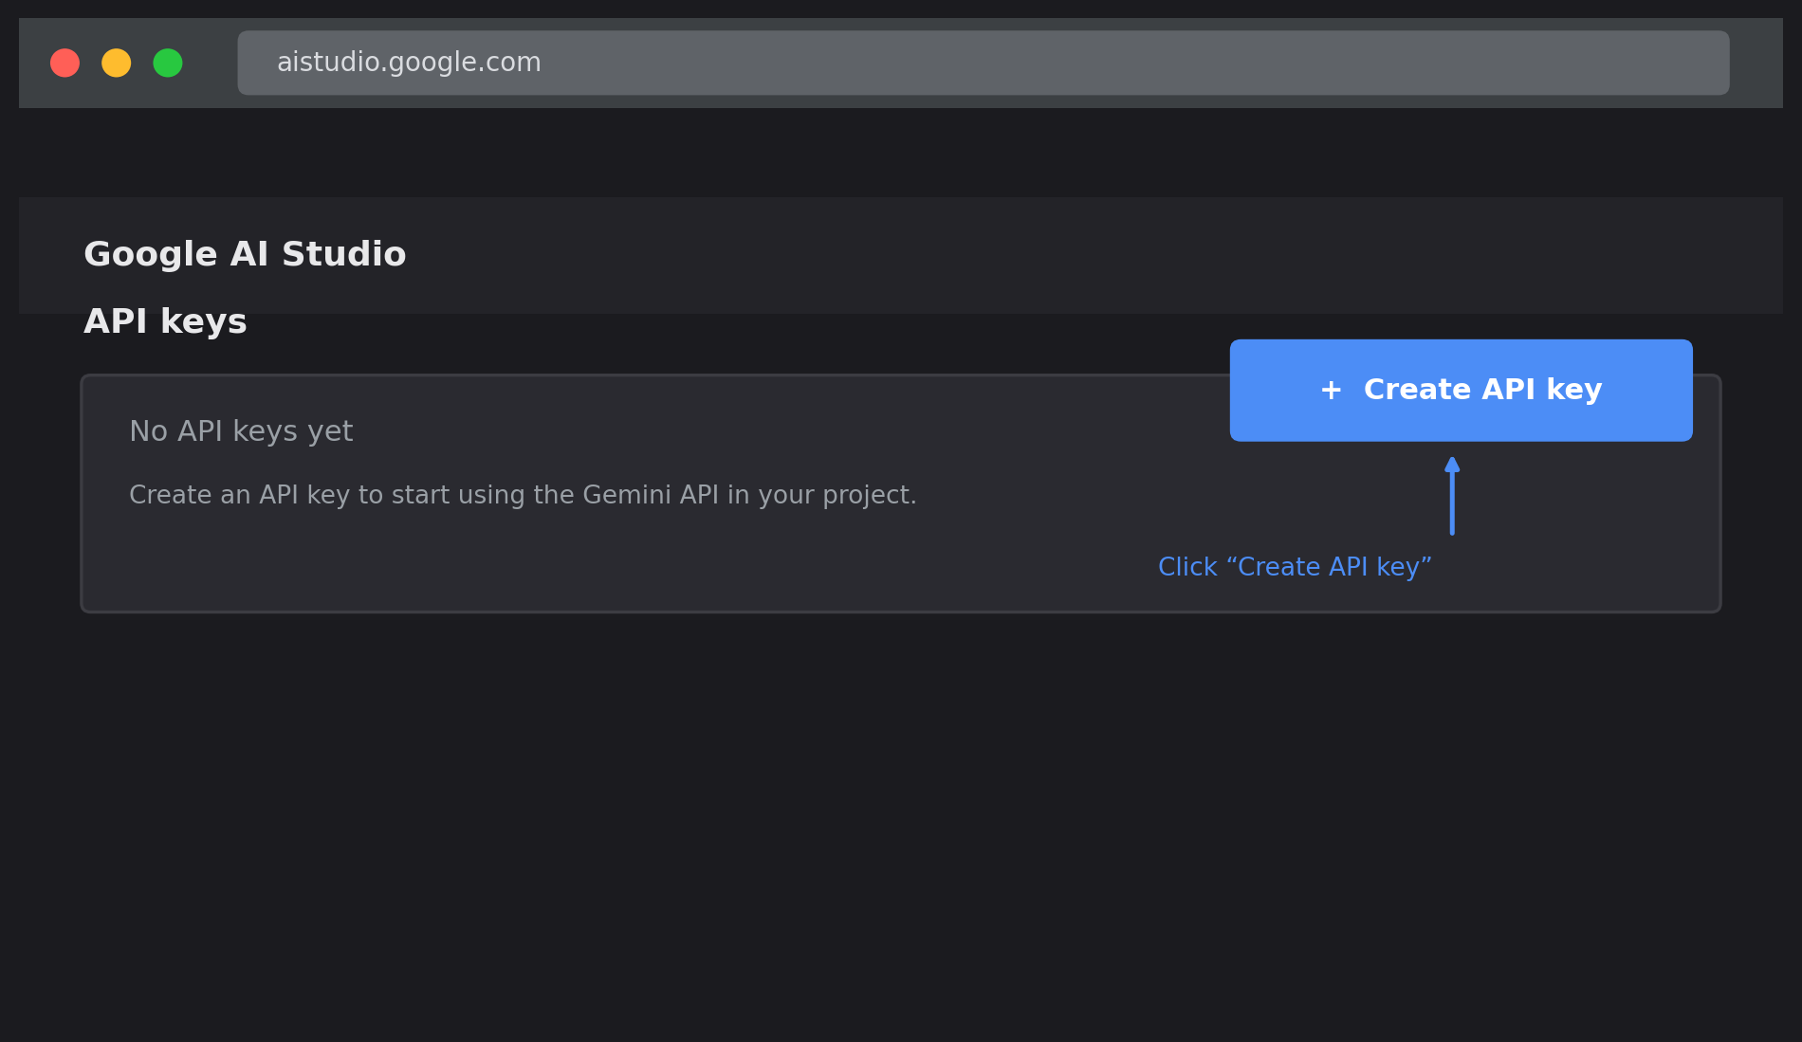
Figure — Illustrative reference: the API Keys page before any key has been created.
- Step 3 — Create a New API Key: Click “Create API Key” and select or create a Google Cloud project to associate it with.
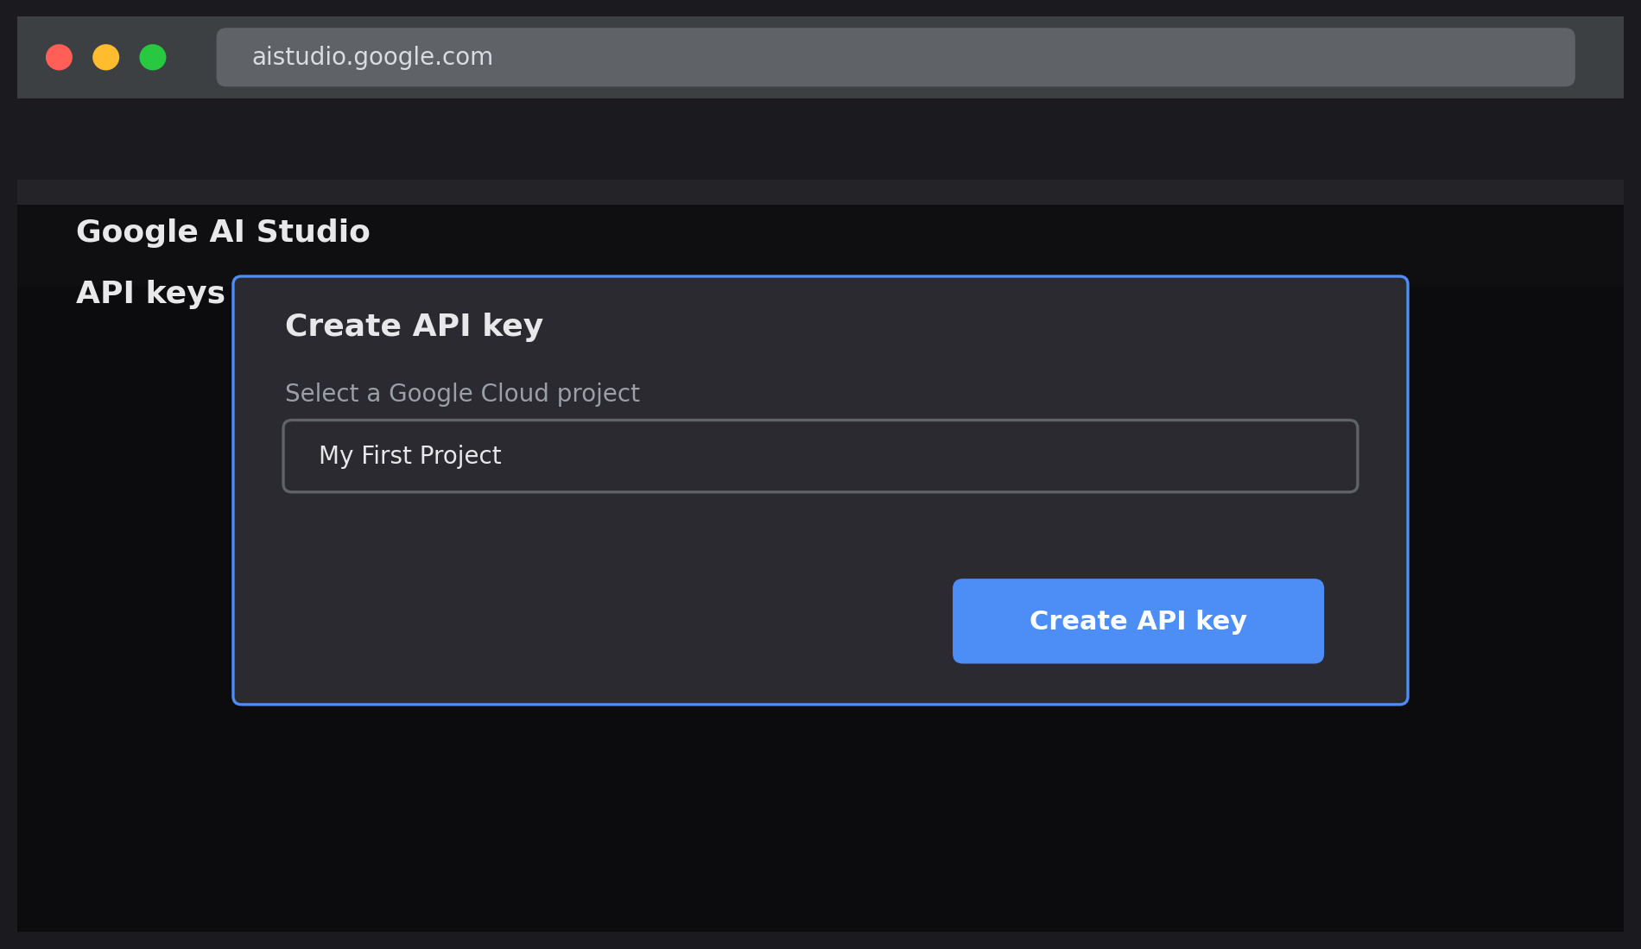
Figure — Illustrative reference: the “Create API key” dialog with a Google Cloud project selected.
- Step 4 — Copy the API Key: Copy the generated key immediately and store it in a safe place.
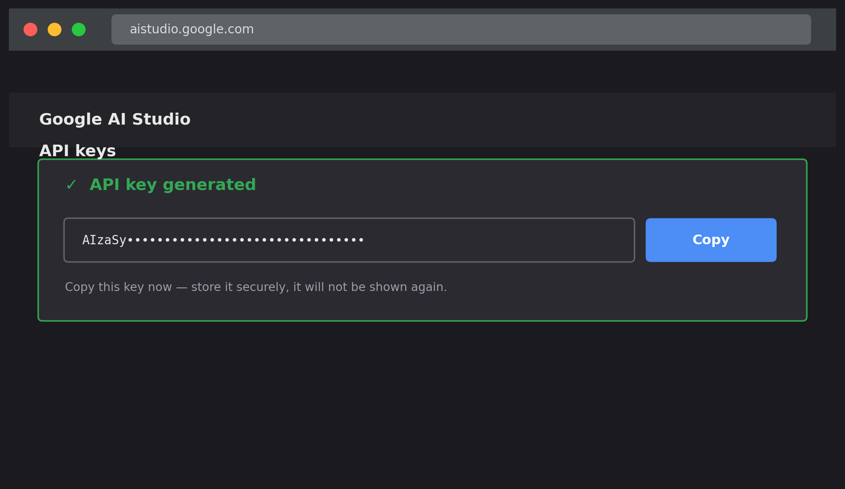
Figure — Illustrative reference: the generated API key, ready to be copied into the project's .env file.
- Step 5 — Add the Key to Your Project: Create a .env file in the project root (if it does not already exist) and add the key:
- Step 6 — Verify the Key is Loaded: The application loads this key automatically at startup using python-dotenv and Pydantic Settings:
from pydantic_settings import BaseSettings

class Settings(BaseSettings):
GEMINI_API_KEY: str
GEMINI_MODEL_NAME: str
EMBEDDING_MODEL_NAME: str
class Config:
env_file = '.env'
- Important — Never Commit Your API Key: Add .env to .gitignore to prevent accidentally pushing the key to a public repository:
Activity 1.2: Research and Select the Appropriate Generative AI Models
- Understand the Project Requirements: Review the specific needs of Multimodal Financial Intelligence RAG System — reading chart/image content accurately, generating high-quality text embeddings, and producing concise, citation-backed answers.
- Explore Gemini's Model Documentation: Review Google's Gemini API documentation to examine available models, including multimodal capabilities, context windows, and free-tier rate limits.
- Evaluate Model Availability: Because Gemini model availability changes over time, verify the current model names before integration — during development, gemini-1.5-pro-latest and gemini-2.5-flash were both found to be deprecated for new API keys, requiring a switch to the currently available gemini-3.6-flash for generation and gemini-embedding-001 for embeddings (replacing the deprecated text-embedding-004).
- Select the Optimal Models: Use gemini-3.6-flash for multimodal chart understanding and grounded answer generation (temperature 0.1 for consistent, factual extraction), and gemini-embedding-001 for text and chart-summary embeddings.
Activity 1.3: Define the Architecture of the Application
- Draft an Architectural Diagram: Create a visual representation of the pipeline, including the ingestion, understanding, indexing, retrieval, and generation stages, plus the FastAPI and Streamlit interface layers (see Figure 1).
- Detail Ingestion Responsibilities: Outline how PyMuPDF extracts text blocks, detects and serializes tables to Markdown, and extracts embedded chart/image elements with page and bounding-box metadata.
- Outline Understanding Responsibilities: Specify how chart/image elements are sent to the Gemini multimodal API with a structured JSON-output prompt requesting chart_type, title, summary, data_points, time_period, and is_financial.
- Describe Retrieval & Generation Integration: Define how a query is analyzed for financial intent and mentioned years, how retrieval falls back to a broader search when a filtered search returns too few results, and how the final prompt instructs Gemini to answer strictly from retrieved context with explicit [Source: element_id] citations.
Activity 1.4: Set Up the Development Environment
- Install Python and Pip: Ensure Python 3.10+ is installed on your machine along with pip for dependency management.
- Create a Virtual Environment: Set up a virtual environment to isolate project dependencies:
financial_rag> python -m venv venv
financial_rag> venv\Scripts\activate
(venv) financial_rag> pip install -r requirements.txt
- Install Core Dependencies: Use pip to install the project's core libraries:
(venv)financial_rag> pip install fastapi uvicorn pymupdf pandas
(venv)financial_rag>pipinstallchromadbgoogle-generativeai langchain-google-genai
(venv)financial_rag>pipinstallstreamlitpython-dotenvpydantic pydantic-settings
(venv) financial_rag> pip install sentence-transformers torch # CLIP visual embeddings
- Configure the API Key: Create a .env file in the project root and add the Gemini API key and model names as shown in Activity 1.1.
- Set Up Application Structure: Create the project directory structure including modules for ingestion, understanding, indexing, retrieval, generation, api, core, and ui, along with data/ folders for raw PDFs, processed elements, and the persistent vector store.

Milestone 2: Core Functionalities Development
Activity 2.1: Develop Core Content Generation Features
Implement the three core pipeline stages — Ingestion, Understanding, and Retrieval — as modular, independently testable components.
- PDF Ingestion & Extraction: Parses financial PDFs page-by-page using PyMuPDF, extracting text blocks (skipping near-empty blocks and those overlapping detected tables), structured tables (converted to Markdown and stored as JSON in metadata), and embedded images (saved as PNG files, classified as “chart” or “image” based on a configurable size threshold).
- Chart & Image Understanding: Sends each chart/image to the Gemini multimodal API with a prompt enforcing strict JSON output — chart_type, title, summary, data_points, time_period, and is_financial — with retry logic and defensive JSON parsing to handle malformed responses.
- Hybrid Semantic Retrieval: Uses lightweight keyword heuristics to detect whether a query wants financial data, wants a comparison, or mentions specific years, then queries ChromaDB with an appropriate metadata filter, automatically falling back to a broader search if the filtered search returns fewer than three results.
Activity 2.2: Implement the Indexing & Vector Storage Layer
Set up the persistent ChromaDB vector store and the embedding pipeline that feeds it.
- Initialize a persistent ChromaDB client and a cosine-distance collection for storing text, table, and chart-summary embeddings.
- Generate embeddings for each extracted element using Gemini's embedding model, using task_type=“retrieval_document” for indexing and task_type=“retrieval_query” for incoming questions — using the correct task type on each side materially affects retrieval quality.
- Flatten and sanitize element metadata (doc_name, page_number, element_type, chart_type, is_financial, time_period) into ChromaDB-compliant primitive types before upserting.
- Implement resumable indexing with an optional max_calls parameter, so that partially completed batches (interrupted by daily API quota limits) can resume without re-billing previously successful calls.

Milestone 3: Core Pipeline Development
Milestone 3 focuses on writing the orchestration logic that ties every pipeline stage together and exposes the system through a FastAPI application. In this milestone, each stage's pipeline.py module is connected end-to-end, and the API surface is defined so the system can be queried or extended with new documents.
Activity 3.1: Writing the Core Application Logic
Define the Core Orchestration Functions: each pipeline module exposes a single top-level function that a caller (CLI or API) can invoke.
# app/generation/pipeline.py
def answer_query(query: str, collection_name: str = "financial_rag",
n_results: int = 8) -> QueryResult:
retrieved_results = retrieve_for_query(query, collection_name, n_results)
return generate_answer(query, retrieved_results)
Define the Core FastAPI Routes: expose ingestion and querying as HTTP endpoints.
@app.post("/query")
def query_endpoint(request: QueryRequest):
try:
result = answer_query(
request.query, request.collection_name, request.n_results
)
return result
except Exception as e:
raise HTTPException(status_code=500, detail=str(e))

@app.post("/ingest")
async def ingest_endpoint(file: UploadFile, max_calls: int | None = None):
# save file -> ingest_pdf() -> enrich_elements_with_understanding()
# -> save_elements_to_json() -> index_document_elements()
...

@app.get("/health")
def health():
return {"status": "ok"}

Implement Defensive Error Handling: wrap Gemini API calls in retry logic with exponential backoff to gracefully handle transient failures and daily rate-limit (429) errors without crashing the batch:
for attempt in range(max_retries):
try:
response = model.generate_content([prompt, image])
return clean_json_response(response.text)
except Exception as e:
logger.warning(f"Attempt {attempt+1} failed: {e}")
time.sleep(retry_delay)
return {"error": str(e)}

Implement Resume-Aware Processing: check for an existing enriched JSON file before re-processing a document, so previously successful chart analyses are reused instead of re-billed against the daily API quota:
if os.path.exists(enriched_json_path):
existing_elements = load_elements_from_json(enriched_json_path)
elements = enrich_elements_with_understanding(
elements, existing_elements=existing_elements, max_calls=max_calls
)
Route Structure Summary:
- GET /health — basic liveness check, returns {"status": "ok"}
- POST /query — accepts {query, collection_name, n_results}, returns a QueryResult (answer, citations, retrieved_elements)
- POST /ingest — accepts a PDF file upload, runs the full ingestion → understanding → indexing pipeline, returns a processing summary
- GET /collections/{collection_name}/stats — returns the total indexed element count for a given collection
Milestone 4: Frontend Development
Milestone 4 focuses on developing a clean, analyst-friendly interface for Multimodal Financial Intelligence RAG System. This involves building a Streamlit application with a query interface and a grounded-citation results display, ensuring analysts can ask questions and verify every generated claim against its original source.
Activity 4.1: Designing and Developing the User Interface
- Set Up the Page Layout: configure the Streamlit page with a wide layout, a descriptive title (“Financial Intelligence Assistant”), and a one-line subtitle explaining the tool's purpose.
- Build the Sidebar: display live indexed-document statistics (total elements in the ChromaDB collection) and a set of pre-filled example queries as clickable buttons, using st.session_state to populate the main query box on click.
- Build the Query Section: a text input for the analyst's question, a “Process Document” / “Analyze” button, and a max-calls control on the upload section to respect the Gemini API's daily free-tier quota.
- Create Separate UI Components for Each Output Type: a markdown-rendered “Analyst Synthesis” answer section, and an expandable “Grounded Sources & Citations” section listing each cited source with its document name, page number, element type icon (text/table/chart), and original excerpt.
Activity 4.2: Creating Dynamic Content Rendering
- Handle Query Submission: on button click, show a loading spinner (“Analyzing financial documents...”) while answer_query() runs, since generation can take several seconds.
- Render Results Dynamically: display the generated answer via st.markdown, escaping literal dollar signs (replacing “$” with “\$”) to prevent Streamlit's markdown renderer from misinterpreting currency amounts as LaTeX math delimiters.
- Render Expandable Citations: for each citation, use st.expander to show the grounded excerpt text and bounding-box coordinates on demand, plus a separate “Inspect Full Retrieved Context” expander showing every candidate element the retrieval step considered, not just the ones ultimately cited.
- Handle Errors Gracefully: wrap the answer-generation call in try/except so a Gemini API error (such as a daily quota limit) shows a friendly message instead of a raw stack trace.

Milestone 5: Deployment
In Milestone 5, the focus is on deploying Multimodal Financial Intelligence RAG System locally to verify correct operation of both the FastAPI backend and the Streamlit interface. This involves configuring the server environment, managing dependencies, and launching the application for real-world analyst use.
Activity 5.1: Preparing the Application for Local Deployment
- Set Up a Virtual Environment: open a terminal in the project root.
financial_rag> python -m venv venv
financial_rag> venv\Scripts\activate
(venv) financial_rag> pip install -r requirements.txt
- Configure Environment Variables: create a .env file in the project root with the Gemini API key and model names. The application loads this automatically using python-dotenv and Pydantic Settings at startup.
Activity 5.2: Local Testing and Verification
- Start the FastAPI Backend:
(venv) financial_rag> uvicorn app.api.main:app --reload
- Once running, open a browser and navigate to “http://127.0.0.1:8000/docs” to access the interactive Swagger UI and test the /health, /query, /ingest, and /collections/{name}/stats endpoints directly.
- Start the Streamlit Interface:
(venv) financial_rag> streamlit run app/ui/streamlit_app.py
- Once running, the interface opens automatically at “http://localhost:8501”. Test the query flow with the pre-built example questions, and verify that citations correctly distinguish between chart-sourced and text-sourced answers.
- Run the Automated Test Suite: verify all pipeline stages pass their unit and integration tests before relying on the deployed application.
(venv) financial_rag> pytest -v
- Test the Ingestion Flow End-to-End: upload a new financial PDF through the Streamlit interface, setting “Max chart analysis calls” below the Gemini free-tier daily limit (approximately 20 requests/day), and confirm the document becomes searchable in the query section afterward.

Exploring the Application's Interface:
Sidebar: Financial RAG Status
Description: The left-hand sidebar provides at-a-glance context before an analyst asks anything. It displays a live count of “Indexed Document Elements” pulled directly from the ChromaDB collection, so the analyst knows how much of a report is currently searchable. Below this, a set of “Example Queries” are shown as clickable buttons — each pre-fills the main question box with a previously validated query, giving new users an immediate, working starting point rather than a blank input field.
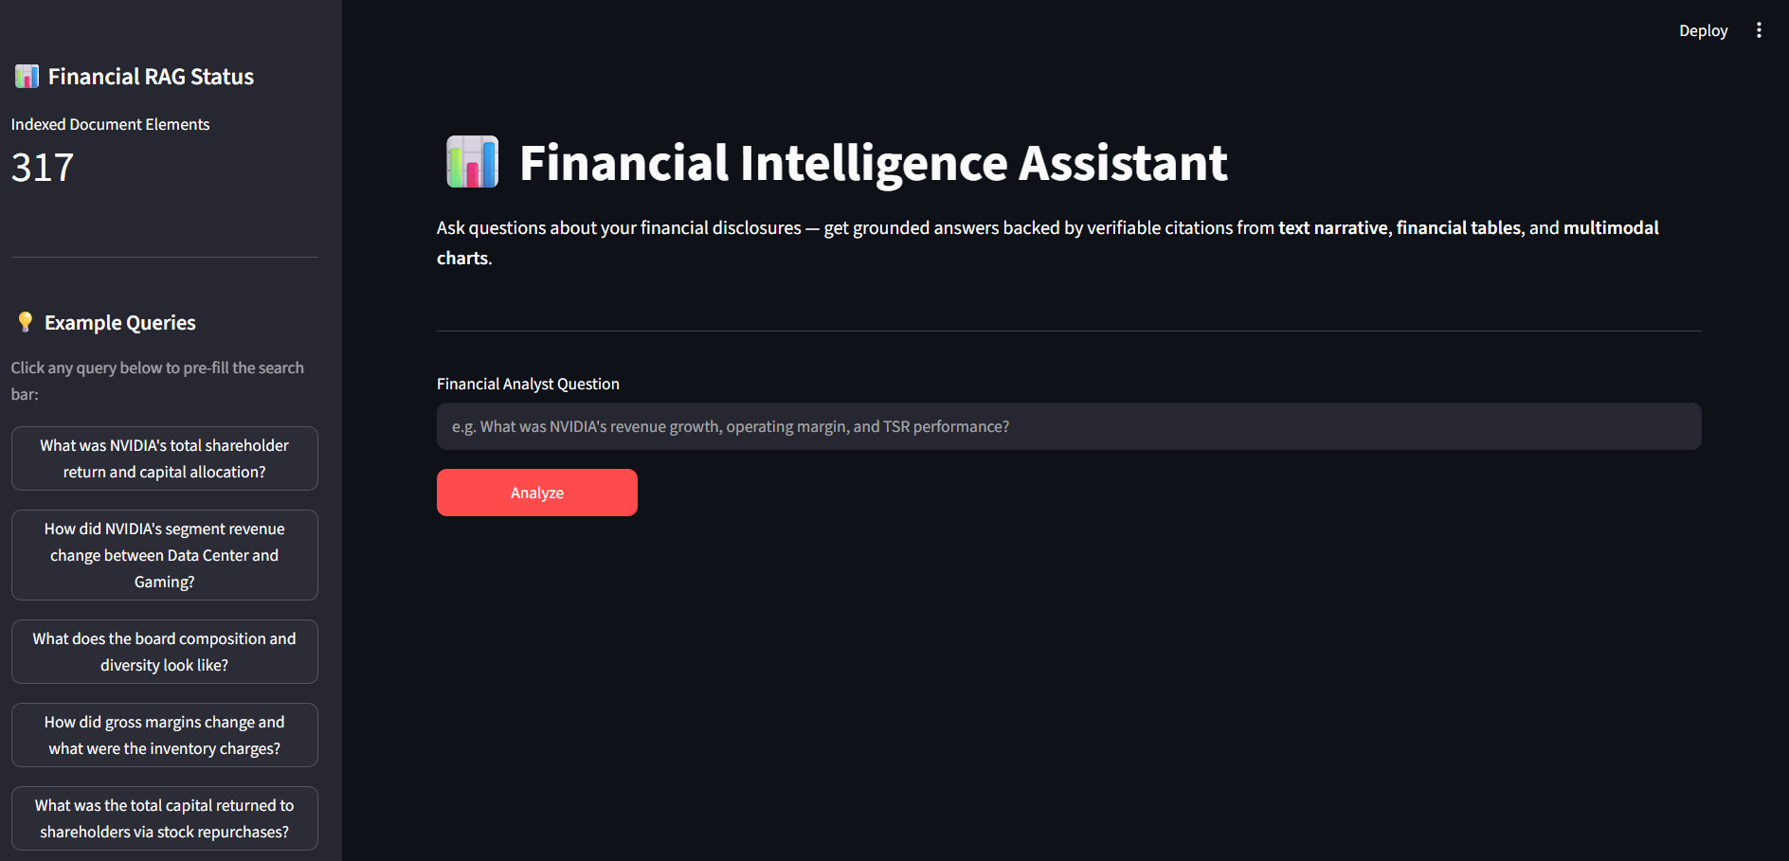
Query Section
Description: The main panel contains the “Financial Analyst Question” text input and an “Analyze” button. On submission, a spinner indicates the system is retrieving and synthesizing an answer, which typically takes five to thirty seconds depending on how many elements the retrieval stage pulls back and how long Gemini's generation call takes.
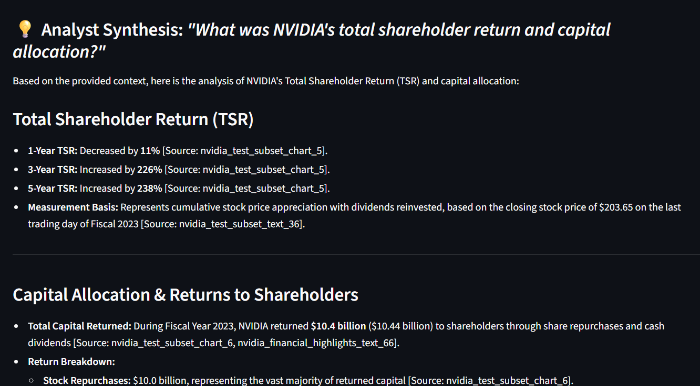
Results Section
Description: Revealed after generation, this section displays the AI's “Analyst Synthesis” as formatted markdown — bolded figures, bullet-organized breakdowns, and inline [Source: element_id] references. Below the answer, a “Grounded Sources & Citations” panel lists every cited source as an expandable card, each labeled with its content type (CHART or TEXT), originating document and page number, and its original excerpt. A separate “Inspect Full Retrieved Context” expander reveals every candidate element the retrieval stage considered, whether or not it was ultimately cited in the final answer — allowing an analyst to audit both the system's reasoning and the completeness of its search.
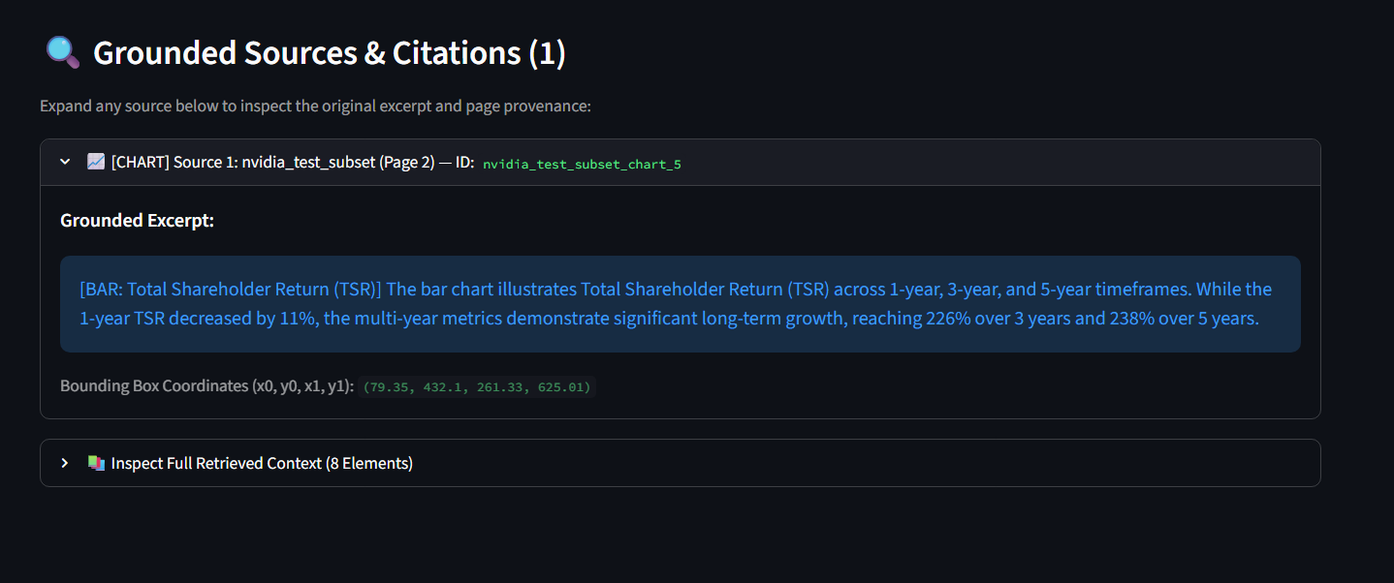

Conclusion:
Multimodal Financial Intelligence RAG System is a multimodal Retrieval-Augmented Generation platform built with FastAPI and Streamlit that closes a critical gap in financial document analysis: the inability of text-only tools to read the data locked inside charts and images. It uses Google's Gemini API to both interpret chart visuals into structured data and synthesize grounded, citation-backed answers, indexed and searched through a persistent ChromaDB vector store with automatic financial-intent detection and fallback retrieval. The project — which included model selection, a six-stage ingestion-to-generation pipeline, a resumable understanding layer to work within free-tier API quotas, and an analyst-facing interface — demonstrates how targeted multimodal AI can eliminate hours of manual document review while remaining fully verifiable through page-level citations.
Looking ahead, the Multimodal Financial Intelligence RAG System offers significant opportunities for expansion. Indexing a document's full page range (rather than a curated subset) would unlock complete multi-year trend analysis; improving table detection for irregular financial table layouts would recover currently-fragmented geographic and segment breakdowns; wiring the standalone CLIP-based visual similarity index into the main generation pipeline would allow “find charts that look like X” style queries; and adding per-document metadata filtering would allow analysts to scope a question to a single company even as multiple reports accumulate in the same vector store. By continuing to refine extraction quality and broadening the range of documents indexed, the platform is well-positioned to evolve from a single-report analysis tool into a comprehensive, multi-company financial research assistant.

